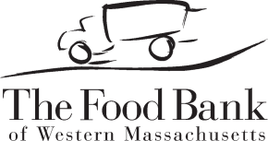

BROWN BAG: FOOD FOR ELDERS

ELIGIBILITY GUIDELINES

July 1, 2021

Please use the guidelines listed below when determining if individuals are eligible to receive a Brown Bag from The Food Bank of Western Massachusetts.

Each household is permitted only one bag each month.

Participants must meet requirements for both age and income.

Age Requirement

Participants must be:
- at least 55 years old, or
- have a documented disability for which they receive SSDI (Social Security Disability Income).

Income Requirement

# of Household Members | Annual | Monthly | Weekly
1 | 23,828 | 1,986 | 459
2 | 32,227 | 2,686 | 620
3 | 40,626 | 3,386 | 782
4 | 49,025 | 4,086 | 943
5 | 57,424 | 4,786 | 1,105
6 | 65,823 | 5,486 | 1,266
7 | 74,222 | 6,186 | 1,428
8 | 82,621 | 6,886 | 1,589
For each additional household member, add: | +8,399 | +700 | +162

Households that participate in the following means tested programs also meet the income requirement for the Brown Bag: SNAP (formerly Food Stamps), AFDC, WIC, Welfare, Medicaid (MassHealth), Supplemental Security Income (SSI), Head Start, Fuel Assistance or Veteran’s Aid. (SSDI and Medicare are NOT INCLUDED in these means tested programs.) All individuals must also meet the age requirement to participate in the Brown Bag program.
This institution is an equal opportunity provider and employer.

